**AIM -->**

Design an automatic night lamp using LDR and variation of voltage show in display.

**CIRCUIT DIAGRAM=**

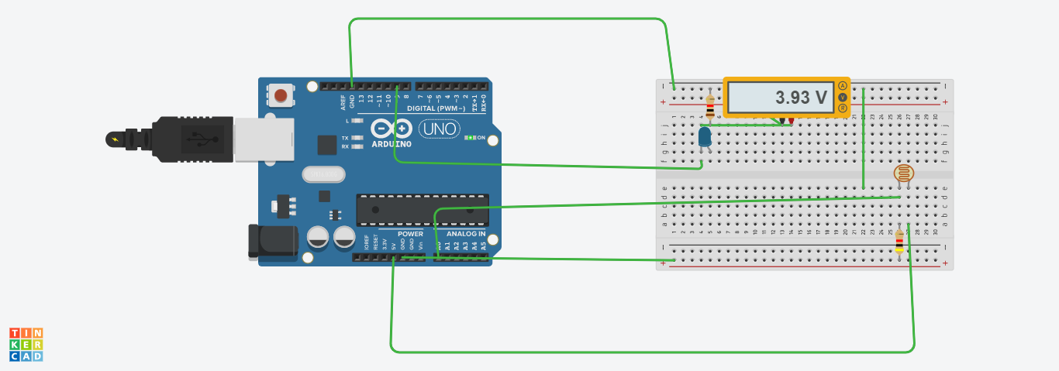

**THEORY🡺**

***Arduino*** refers to an open-source electronics platform or board and the software used to program it. **Arduino** is designed to make electronics more accessible to artists, designers, hobbyists and ayone interested in creating interact

A **breadboard** is a construction base for prototyping of electronics.

A ***circuit*** is a closed path that allows electricity to flow from one point to another. It may include various electrical components, such as [transistors](https://techterms.com/definition/transistor), resistors, and capacitors, but the flow is unimpeded by a gap or break in the circuit.

LDR(Light Dependent Resistor):-

An **LDR** or photoresistor is **made** any semiconductor material with a high resistance.whenever light falls over ldr the light photons are absorbed by the semiconductor lattice and some of their energy is transferred to the electrons.

DISPLAY:-

It is used to print value to analyse the variation.

***Kirchhoff's Current Law (KCL)*** is Kirchhoff's first law that deals with the conservation of charge entering and leaving a junction. ... His current law states that for a parallel path the total current entering a circuits junction is exactly equal to the total current leaving the same junction.

A ***loop*** is a programming structure that repeats a sequence of instructions until a specific condition is met. Programmers use loops to cycle through values, add sums of numbers, repeat [functions](https://techterms.com/definition/function), and many other things.

**LEARNING AND OBSERVATION=**

* Whenever the LDR sense darkness or brightness then the led get turn on and off respectively.and also we can observe the variation of voltage.
* Learned about ***lDR*** and ***Arduino***. Circuit set up is also clear.
* Use of LDR for different purpose.

**PROBLEM AND TROUBLESHOOTING=**

1. Setting up a connection.
2. Errors in code.
3. Port was not selected.
4. Proper Power supply.
5. Connect display in proper pinmode.

**PRECAUTIONS🡺**

1. Don't plug **in** an LED and LDR without a current limiting resistor.
2. Don't supply it with more then 9V.
3. Circuit must be correct.
4. proper terminal should be connected in proper pinmode according to code.

**LEARNING OUTCOMES🡺**

1. Learned programming concepts using ldr along with Arduino specific programming.
2. Usage of a wide variety of hardware and components and prototype your projects using a breadboard.
3. Understand what an Arduino is and how it work and learnt how to use an Arduino safely.
4. Understand the properties of semiconductor and how it behaves when light fall over it.